

Project Title
  - Group NO:
  - Team MEMBERS and Student IDS
  - (Paste the Link to your website here)
2025
Semester 2
(Word Count)

Table of Contents
(Generate Automatically)

1 Introduction

1.1 Background and Motivation
- Explain what the BITRE dataset represents
- Select one of the following BITRE enforcement dashboards as the focus of your project:
  - Speeding
  - Mobile Phone Use
  - Drug Tests
  - Seatbelt (non-wearing)
  - Unlicensed Driving
- Explain why road safety enforcement is important.
- Identify your target audience (e.g., policymakers, general public, transport analysts).
- Define the problem with the chosen dashboard.
  - What are lacking?
  - Examples: limited interactivity or filtering options; Does not visualise new detailed data (e.g. age, detection method); Difficult for users to identify trends or compare jurisdiction easily.
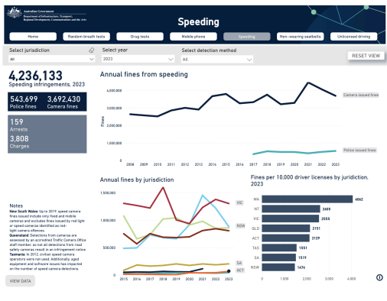
Figure 1: …
- Describe the user tasks your visualisation will enable.
  - List 5 key activities that users will be able to perform, such as
    - Compare jurisdictions or time periods
    - View offence rates per 10,000 licences

1.2 Visualisation Purpose
- Define the specific questions users should be able to answer or what you are trying to achieve by making the visualisation
- List five (5) research questions that your visualisation will address.
  - These questions should guide your visualisation design. For example:
    - Which jurisdiction records the highest fines per 10,000 licences?
    - How did enforcement activity change during COVID-19 (2020–2021)?
- List the benefits of the completed visualisation.
  - Explain how the visualisation will support decision-making or raise public awareness.
  - Example points:
    - Helps policymakers identify areas needing targeted enforcement.
    - Increases public transparency on enforcement trends.
    - Encourages safer driving behaviour through data visibility.

2 Data

2.1 Data Source and Governance
- Identify the original data source(s) and provide links where applicable.
- Identify which dataset(s) you used:
  - police_enforcement_2024_fines.csv
  - police_enforcement_2024_positive_drug_tests.csv
- Include a brief data summary table (e.g., number of records, key attributes, update frequency)
Table 1: …
Dataset | Records | Key Attributes | Time Period | Source | Update Frequency
Fines | (count) | Year, Jurisdiction, Offence Type, Detection Method, … | 2008–2024 | BITRE | Annual
Drug Tests | (count) | Year, Jurisdiction, Positive Rate, Age Group … | 2008–2024 | BITRE | Annual
- Discuss data governance, including:
  - Data collection process: Describe how the data is gathered and reported by BITRE and its partner agencies. Mention the source agencies and the reporting frequency.
  - Data quality assessment: Describe how the data is gathered and reported by BITRE and its partner agencies. Mention the source agencies and the reporting frequency.
  - Security, privacy, and ethical considerations: Explain how data confidentiality is maintained and confirm that the dataset contains no personal identifiers. Acknowledge responsible and ethical use of open government data.
  - Review the data dictionary and the datasets provided to discuss the three points above
- Demonstrate how the data supports answering the questions from Section 1.2
Table 2: …
Research Question | Relevant Dataset(s) | Key Attributes / Variables Used | How the Data Supports the Question
Which jurisdiction records the highest fines per 10,000 licences? | police_enforcement_2024_fines.csv | Year, Jurisdiction, Fines, Detection Method, Population/Licences | Enables calculation of fines per capita to compare enforcement intensity between states and territories.
Q2
Q3
Q4
Q5

2.2 Data Processing and Analysis

2.2.1 Key attributes and data types
- List key attributes and their data types (categorical, ordinal, interval, ratio/quantitative)
Table 3: …
Key Attribute | Data Type | Measurement Type | Short Description
Jurisdiction | String | Categorical | State or territory
Detection Method | String | Categorical | Camera or police-issued
Fines | Number (double0 | Quantitative | Number of fines issued
Year | Number (integer) | Interval | Year of enforcement

2.2.2 Data Processing
- Describe the data cleaning process (in KNIME), including:
  - Handling missing values
  - Removing duplicates
  - Normalisation, transformation, and derived variables
  - Calculated derived metrics (e.g. “Fines per 10,000 licenses”)
- Data filtering and joining datasets
Table 4: …
KNIME Node Used | Purpose | Output
Missing Value node | To detect and fill or remove missing values from numeric or categorical columns. | Replaced missing offence counts with “0” or excluded incomplete jurisdiction-year rows.
Math Formula / GroupBy node | To create new calculated columns such as rates or totals. | Derived metric: Fines per 10,000 licences = (Total Fines / Number of Licences) × 10,000.
Row Filter / Rule-based Row Filter | To select only relevant offences or years for visualisation. | Filtered data to 2010–2024 for selected dashboard category (e.g., Drug Tests).
Joiner node / Concatenate node | To combine multiple datasets (e.g., fines and drug tests) into one table for comparison. | Merged datasets using common keys (Year, Jurisdiction) to create a unified dataset for analysis.
- Include a screenshot of the KNIME workflow for data processing
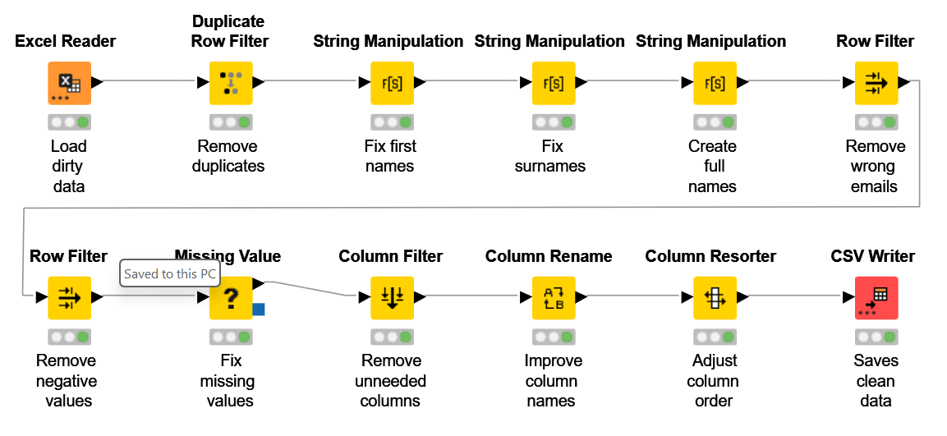
Figure 2: …(Example)

2.3 Data Exploration
- Conduct exploratory data analysis using KNIME.
- Provide summary statistics (basic descriptive statistics) and data visualisations to understand patterns and outliers
- Include a screenshot of the KNIME workflow for data cleaning
Table 5: …
KNIME Node Used | Purpose of the Node | Example Output / Description
Statistics | Generates basic descriptive statistics (mean, min, max, standard deviation). | Summary table showing average fines and test counts per year.
Data Explorer | Provides an overview of column distributions, missing values, and outliers. | Identifies missing Jurisdiction values or abnormal Positive Rates.
GroupBy | Aggregates data to calculate totals or averages per category. | Summarises total fines by Year and Jurisdiction.
Box Plot | Detects outliers and visualises data spread. | Visualises high fine counts in NT compared to other states.
Bar Chart | Displays category comparisons. | Shows number of fines per offence type.
Line Plot | Shows trends over time. | Plots fines or tests from 2008–2024.
Figure 3: …(Example only)
- Discuss initial observations (a summary of what you discovered)
- Reflection:
  - What insights or anomalies did you find?
  - Which variables are most relevant to your research questions?
  - Any challenges (e.g., missing data or inconsistent reporting)?
Table 6: …
Research Question | Key Findings from KNIME EDA | Initial Observations / Insights | Charts Produced in KNIME
1. Which jurisdiction records the highest fines per 10,000 licences? | KNIME GroupBy node shows NT and WA have highest fines per capita; ACT lowest. | Jurisdictional variation is clear — possible link to enforcement intensity. | Bar chart of total fines by jurisdiction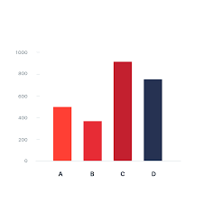
Q2
Q3
Q4
Q5

3 Visualisation Design
This section should include:

Website Design
- Create a wireframe of your webpage layout, showing:
  - Navigation structure
  - Placement of headings, text, and charts
  - Provide a wireframe using tools like Figma, Miro, PowerPoint (or a hand-drawn sketch).
  - Describe the planned structure and user flow of the website in paragraphs
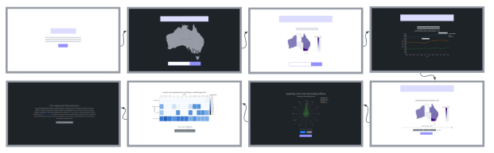
Figure 4: …
- Design a storyboard explaining how users will interact with your D3.js website.
  - Describe the user journey (what they click, what changes on screen).
  - Example Storyboard: A user selects “Victoria” from the dropdown → line chart updates to show speeding trends from 2010–2024 → hovering over 2020 shows note “COVID-19 travel restrictions.”
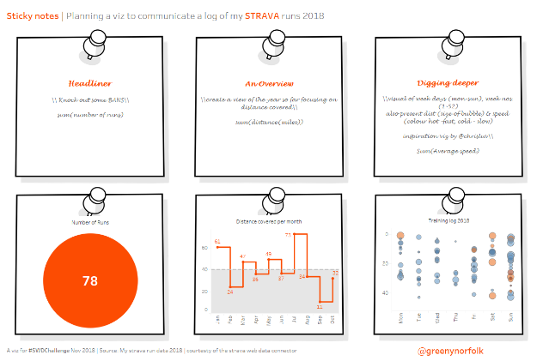
Figure 5

3.2 Visualisation Design
- Explain the chart types chosen (e.g., bar, scatter, line, area, Sankey, parallel coordinates etc) and why they are appropriate.
Table 7: …
Research Question | Chart Type | Why It’s Appropriate | Data Type Represented
1. Jurisdiction with highest fines per 10,000 licences | Bar Chart | Clearly compares discrete categories (states/territories). | Categorical (Jurisdiction) + Quantitative (Fines per 10,000)
1. Jurisdiction with highest fines per 10,000 licences | Choropleth Map | Shows geographical variation of fines effectively. | Spatial (Jurisdiction) + Quantitative (Rate)
Q2
Q2
Q3
Q4
Q5
- Discuss adherence to good design principles, including:
  - Graphical integrity (avoiding misleading charts)
  - Accessibility (colourblind and web-friendly palettes, font size)
  - Scalability (responsiveness across different screen sizes)
- Explain how graphical elements (colour, shape, size, annotations) are used to represent differences effectively.
- Justify colour choices, labelling, and layout decisions.
- Describe how you will use annotations and tooltips enhance user understanding.

3.3 Interaction Design
- Describe interactive features (e.g., zooming, filtering, tooltips, animations) and their role in improving user experience.
- Provide a table of interactions, explaining:
  - The interaction method (hover, click, drag, etc.)
  - The expected user behaviour and response
Table 8: …
Interaction Feature | Interaction Method (User Action) | System Response / Behaviour | Linked Research Question(s) | Purpose and User Experience Benefit
Tooltip on Hover | Hover over bar, line, or map point | Displays a popup showing details (e.g., year, jurisdiction, fines, detection method, or positive rate). | Q1 – Jurisdiction with highest fines; Q4 – Positive drug test rates | Provides “details on demand” without cluttering visuals; helps compare fine or test rates precisely.
Dropdown Filter | Select jurisdiction or offence type from a dropdown menu | Updates all charts to display selected category only. | Q1, Q2, Q3 – Compare jurisdictions and enforcement types | Enables focused comparison; users can easily switch between states or offence types.
Time Slider / Brush | Drag or select a time range on timeline | Filters charts to show selected years only. | Q2 – COVID-19 (2020–2021) impact on enforcement | Allows users to isolate and examine specific periods (e.g., lockdown years) for temporal analysis.
Animated Transitions | Automatic when filters or time slider change | Smoothly updates charts to reflect new data. | All questions | Preserves context and helps users track changes during interaction.

4 Iteration and Validation

4.1 Testing and refinements
- Describe the iterative process of testing and improving the visualisation
- Include feedback received (from peers, users, or instructors) and how changes were made in response
- Provide before-and-after comparisons using screenshots/sketches
- Discuss any adjustments made to design due to programming issues
- Discuss accessibility features of design/programming
Table 9: Iteration Plan (example)
Week | Focus / Iteration Stage | Deliverables / Outputs | Feedback Target | Feedback Received & Improvements Planned
Week 9 | Project Planning & Setup | Selected BITRE topic, defined 5 research questions, created initial wireframe and storyboard. | Tutor | (To be filled after Week 9 stand-up)
Week 10 | Initial Design (Prototype 1) | KNIME analysis results, wireframe updates, draft D3.js chart layout. | Tutor | Tutor suggested improving chart alignment and label readability. Plan to adjust font size and add chart titles.
Week 11 | Refined Design (Prototype 2) | Interactive charts, improved colour scheme and accessibility features. | Peer & Tutor | Feedback to add tooltips and consistent colour palette. Plan to implement hover tooltips in D3.js and standardise chart colours.
Week 12 | Final Design (Prototype 3) | Completed D3.js dashboard, full interactivity, usability test results. | Final Tutor Review | Feedback to simplify navigation and legend clarity. Plan to redesign header and legend elements using D3.js SVG.

Table 10: Iteration Documentation Summary (Example)
Iteration / Week | Screenshot (Insert Image) | Feedback Received | Changes Made | Reflection / What Improved
Iteration 1 – Week 10 | (Insert image of Prototype 1 here) | “Improve chart alignment and label readability.” | Adjusted font size, added chart titles, improved layout spacing. | Layout now clearer and easier to read. Font hierarchy enhances data interpretation.
Iteration 2 – Week 11 | (Insert image of Prototype 2 here) | “Add tooltip interaction and consistent colour scheme.” | Implemented hover tooltips in D3.js, applied consistent blue-orange palette. | Increased interactivity and readability. Charts now visually coherent.
Iteration 3 – Week 12 | (Insert image of Prototype 3 here) | “Simplify navigation bar and improve legend clarity.” | Redesigned navigation bar and legend using D3.js SVG. Adjusted alignment for smaller screens. | Navigation now smoother; legends are more intuitive, improving storytelling flow.

4.2 Usability evlauation
- Conduct a usability evaluation
- After the final iteration:
  - Conduct a short usability test with 3–5 participants.
  - Provide 2–3 test tasks (e.g., identify highest offence rate, compare states).
  - Collect feedback and summarise findings.
- Include:
  - Participant details (anonymised)
  - Method used (observation, think-aloud, etc.)
  - Summary of key findings and adjustments made (reflection.
Table 11: Participant Summary (Example)
Participant ID | Background | Familiarity with Data Visualisations | Device Used | Testing Method
P1 | Postgraduate student in Data Science | High | Laptop (Windows) | Think-Aloud Observation
P2 | Undergraduate in Business Analytics | Medium | Laptop (Mac) | Observation and Notes

Table 12: Usability Test Tasks and Methods
Task ID | Test Task Description | Purpose of the Task | Method Used | Success Criteria
T1 | Identify which jurisdiction had the highest fines per 10,000 licences in 2024. | Test the clarity of comparative charts (bar/choropleth). | Observation + Think-Aloud | Participant can locate and interpret correct data within 30 seconds.
T2 | Compare speeding offences before and during COVID-19 (2019–2021). | Assess how well users can filter and understand time-series data. | Think-Aloud | Participant uses slider or filter to isolate time range and explains trend.

Table 13: Summary of Key Findings and Adjustments
Issue / Observation | User Feedback | Adjustment / Improvement Made | Impact on Usability
Tooltip text was small on tablet view. | P3 reported difficulty reading tooltip text. | Increased tooltip font size and added background opacity for contrast. | Improved readability on mobile and tablet.
Legend not easily understood. | P2 and P4 found legend colours ambiguous for “Camera” vs “Police”. | Added labels and consistent colour scheme across charts. | Enhanced clarity and colour association.

5 Conclusion and Future Improvements
- Summarise what your visualisation revealed about the chosen topic.
- Reflect on challenges and lessons learned (data, design, interactivity).
- Suggest future improvements, such as:
  - Adding real-time BITRE API data
  - Integrating accident/fatality data
  - Applying predictive analytics

References
References consulted (blogs, books, academic papers, discussion/help forums - for both design and programming)

Appendices
- Gen AI Declaration (how AI tools were used)
- Usability evaluation test materials (notes and screenshots)
- Notes/data collected in usability evaluation (if used)
- KNIME workflow screenshot (if any)

